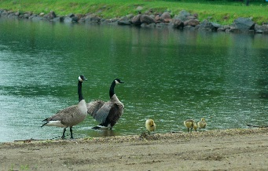*[](https://www.facebook.com/pages/The-Shores-at-Five-Island/280939448752116)*

***The***

***Splash Report***

**April**

**2015**

C:\Users\Owner\Dropbox\The Shores at 5 Island\Logo\TheShores_swoosh.png

**Dockside**

**at The Shores**

***Dockside is our*** *public bar and lounge that is attached to the community center. The entrance is on the North side of the building. It is the host site of the Pro-Shop where golfers can pay green fees, rent carts, and purchase golf accessories.*

***Dockside*** *welcomes not only golfers - but boaters, fishermen, campers, and the general public to enjoy drinks and appetizers both in the lounge and veranda!*

*We hope to see everyone at* ***Dockside*** *soon!*

***June 1st is The Shores projected opening date!***

C:\Users\Owner\Dropbox\The Shores at 5 Island\Logo\TheShores_swoosh.png

***Official Opening Day only 2 months away!***



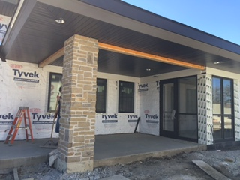

**“Dockside” at The Shores**

***Public Bar/Lounge and Pro-Shop***

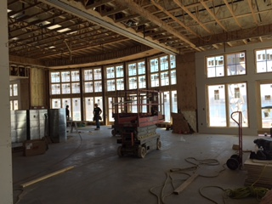

***Ballroom is***

***coming along nicely!***

*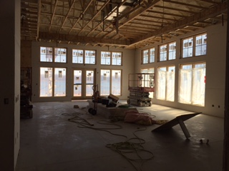*

***View of the***

***POET BIORIFINIG ROOM***

***Thank you to everyone who attended our***

***Sneak Peek Open House Event!***

IOWA TRUST & SAVINGS BANK COMMUNITY CENTER

***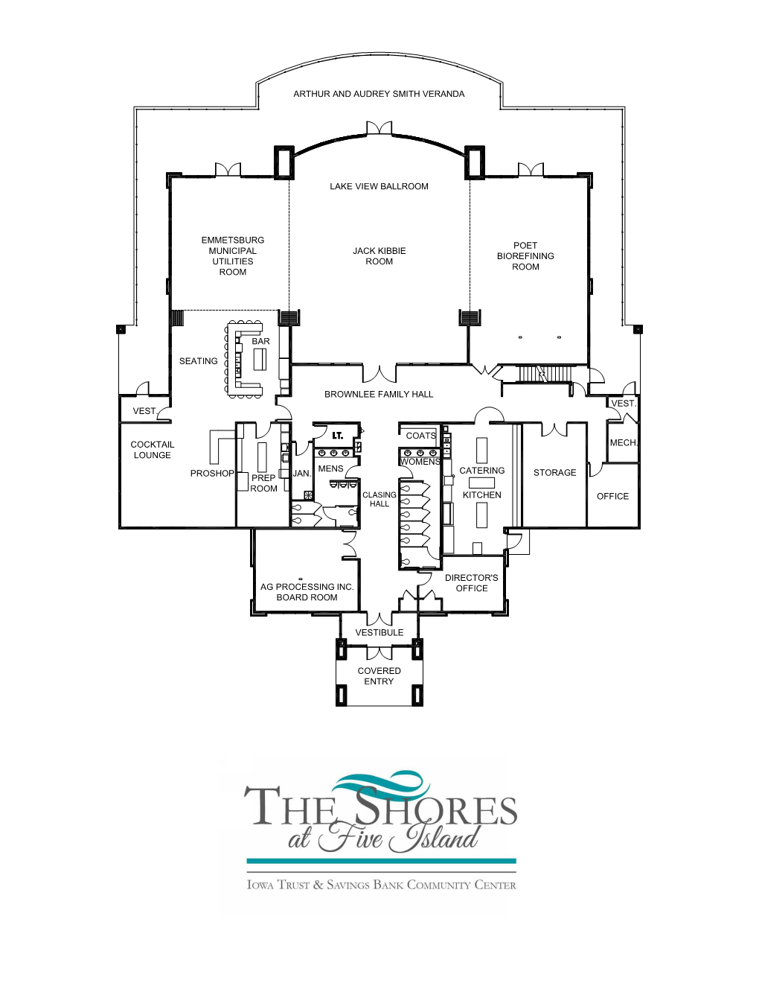***

*Additional location donors include:*

Hughes Pharmacy

(Hoyman Family)

Vestibule

MidAmerican Energy

Catering Kitchen

Lundgren/Reichert

Pro Shop

PACGDC

Director’s Office

Ausborn/Brown

“Dockside”

Cocktail Lounge

|  |  |  |  |  |  |
| --- | --- | --- | --- | --- | --- |
| **MEETING ROOMS** | **SQUARE FOOTAGE** | **DIMENSIONS** | **BANQUET** | **THEATER** | **CONFERENCE** |
| LAKEVIEW BALLROOM | 4,331 | 100 ’x 44’-2” | 320 | 400 |  |
| JACK KIBBIE ROOM | 2,230 | 43’ x 53’ | 144 | 231 |  |
| POET BIOREFINING ROOM | 1,226 | 28’ x 44’-2” | 80 | 102 |  |
| EMMETSBURG MUNICIPAL UTILITIES ROOM | 875 | 28’ x 31’-3” | 56 | 64 | 20 |
| AG PROCESSING INC. BOARD ROOM | 445 | 24’-6” x 19’-4” | 24 | 32 | 14 |
| **HALLS** |  |  |  |  |  |
| CLASING HALL | 468 | 9’-2” x 45’ |  |  |  |
| BROWNLEE HALL | 710 | 49’-9” x 13’-5” |  |  |  |
| **OUTDOORS** |  |  |  |  |  |
| ARTHUR & AUDREY SMITH VERANDA | 2,112 (FRONT ONLY) | (L - 33’-4” x 16’-5”)  (C -58’-9” x 16’-5”)  (R - 33’-4” x 16’-5”) | 32  80  32 |  |  |